Advanced TENORM Services
7675 East Pike
Norwich, Ohio 43767

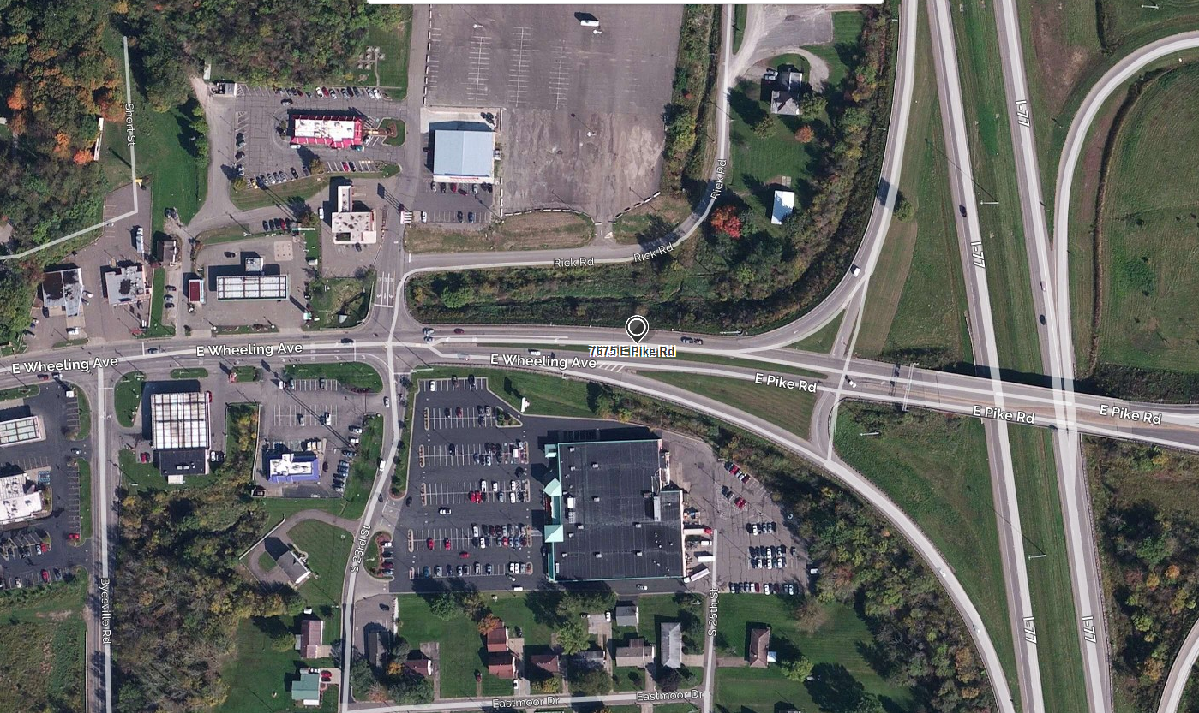

Advanced TENORM Services
151 University Drive
West Liberty, KY 41472

