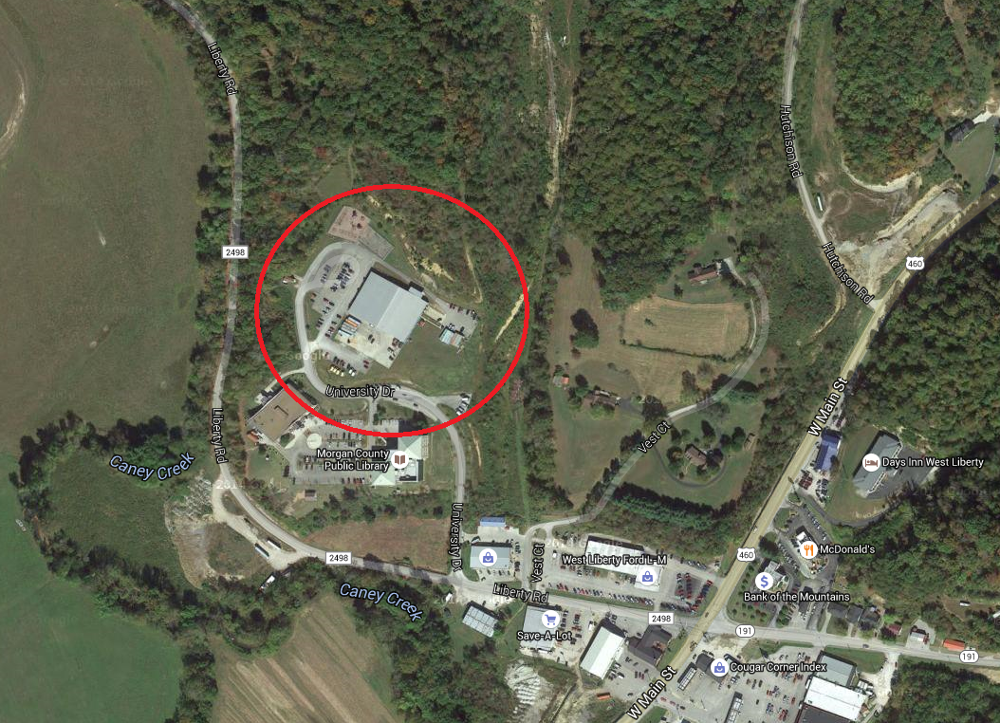
Advanced TENORM Services
151 University Drive, West Liberty, KY 41472

