Irvine, KY - School Site Visits
High School and Middle School

Saturday, February 27
9:10 AM – 1:58 PM

Sample Number | GPS Coordinates | Meter CPS
F-1 | 37.73673; 83.98611 | 37
F-2 | 37.73663; 83.98605 | 35-36
F-3 | 37.73684; 83.98617 | 33-36
F-4 | 37.73676; 83.98641 | 48
F-5 | 37.73669; 83.98665 | 26
F-6 | 37.73704; 83.98628 | 27
F-7 | 37.73770; 83.98629 | 25-26
F-8 | 37.73692; 83.98669 | 18
F-9 | 37.73679; 83.98706 | 22

Notes:

- Counts in front of school building; 9 - 12 cps (5-8 with same meter used for measurements in table.)
- Counts increased as one walked across grounds from front of building to highway running parallel to school: 15 – 23 cps (Different handheld meter than one used for table.)
- Counts on grounds adjacent to entrance road leading from highway to front of building: (23-25 cps) (Different handheld meter than one used for table.)
- Counts from highway to gate at landfill entrance increased: 22, 26 to 27, 37, 36; general trend was an increase in counts from school to landfill entrance which could potentially be attributed to particulate deposition on the surface of shale geology.

Attachment: Figure, notes and photographs taken in field at time of measurements with handheld instruments.

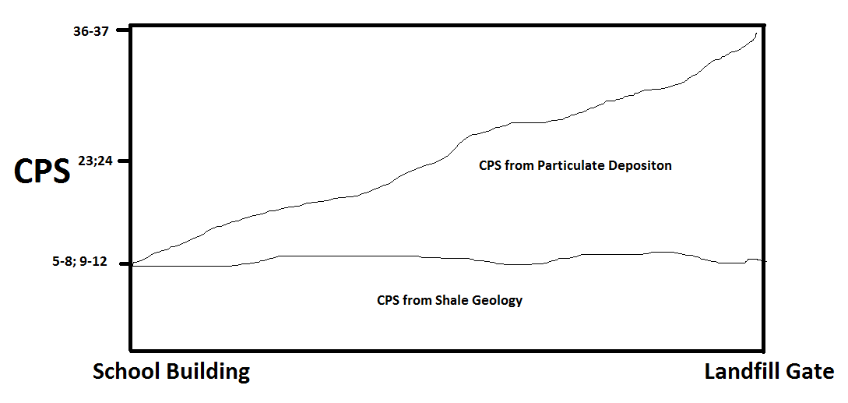
Not drawn to scale, just for illustrative purposes!

Results:
Appears school grounds approaching entrance to school and areas surrounding entrance to school may be contaminated due to particulate deposition (radionuclide containing dust from waste). Future inhalation risks to students and employees may occur when grass is cut resulting in resuspension of deposited particles containing radionuclides. Also maintenance workers that change out filters on HVAC system at school could potentially be at risk as well. HVAC ductwork needs to be sampled for particle deposition. If found, that would indicate there was an inhalation risk of radionuclides to students and employees who were exposed to radionuclides when waste disposal incidents occurred in 2015. These types of radionuclides pose a significant inhalation risk and external exposure is not an appreciable concern.
Recommend measures to prevent future exposure risk by having maintenance workers wear respirators when servicing the HVAC system and replacing the air handling filters until the HVAC ductwork is confirmed to be contaminant free.
Also recommend that a thin layer of top soil be spread on school grounds and across the street in front of the landfill entrance to minimize re-suspension of previously deposited particulate matter resulting from vehicle traffic to and from landfill and any windblown particles (dust) from landfill disposal areas.
These results and recommendations were shared by George Partridge with Danny Anderson and Jon Maybriar with the Division of Waste Management on Friday, March 4th in Jon Maybriar’s office in a meeting that was held from 11:03 AM – 12:35 PM at 200 Fair Oaks Ln, 2nd Floor, Frankfort, Kentucky.
Attachments
- Photos
- Field Notes
Field Inspectors:

George Partridge (DWM)
George Weems (DWM)
Anjan Bhattacharyya (CHFS)

Photographs from Site Visit on February 27, 2016

